Image Processing Lab Manual

List of practicals

- Study of Matlab environment

- Implementation of Matlab commands, functions and programming constructs

- Write a matlab program to perform to perform arithmetic and logical operations on image

- Write a matlab program to zoom an image using pixel replication and to implement Grey-level resolution

- Write a matlab program to implement Point processing operation – Negation of an image and Thresholding of an image

- Write a matlab program to implement Contrast Stretching operation

- Write a matlab program to implement Bit-plane Slicing

- Write a matlab program to plot a Histogram of an image

- Write a matlab program to implement Filtering in spatial domain –a)Averaging filter (b)Median filter

- Write a matlab program to implement Filtering in frequency domain –a)Low pass filter (b) High pass filter

11) Write a matlab program for edge detection –a) Prewitt operator (b) Sobel operator

Practical 1
Aim: Study of Matlab environment

Theory: What is Matlab?

- Matlab (matrix laboratory) is a high performance language and software for technical computing developed by MathWorks.
- MATLAB is an interactive, interpreted language that is designed for fast numerical matrix calculations
- It allows
- Maths and computation
- Algorithm development
- Modelling, simulation and prototyping
- Data analysis and visualisation
- Scientific and engineering graphics

- It is an interactive system (all data always in memory) with the following key facts:
- The basic data element is an array
- No declaration (or prototyping of functions) required
- All data represented as doubles
- In script mode or command line mode, data is always accessible and in memory.

- The desktop of matlab has the following panels:

Current Folder - This panel allows you to access the project folders and files.
Command Window - This is the main area where commands can be entered at the command line. It is indicated by the command prompt (>>).
Workspace - The workspace shows all the variables created and/or imported from files.
Command History - This panel shows or rerun commands that are entered at the command line.
- There is two ways to give instructions to matlab:
- On the command line, after the prompt ">>": if you type an instruction, matlab executes it and gives you the result.
- Through a script, whose code is written in a text file with the “.m”extension. Scripts contain lists of instructions, just as could be written on the command line. To run the file, we can use “Run” option or Run the file, in the command line, by typing:>>filename
- There are only a few data types in matlab. The main one is a matrix of doubles and most functions will only work with it. The second useful on is the uint (unsigned integer) type used to store images and limited to the [0,255] range.
- Bear in mind that in matlab, all data is stored into matrices.
- A scalar (real) number is a 1 by 1 matrix. A vector is a 1 by N matrix.
The help command:
You can get help on all commands in matlab by typing (beware, matlab is case sensitive!):
>> help command
Ex: >> help cos

The lookfor command:
If you do not know what is the name of the matlab command you want to use, the lookfor command is used
For instance, if you are looking for the cosine or related functions, type

>>lookfor cosine
matlab comes back with all matlab functions related to cosine with a short description

- The percent symbol (%) is used for indicating a comment line.

Ex: y = 5% assign the value 5 to y
- Commonly used operators are -
Ex: >> 10/5
ans = 2

>> 10\5

ans = 0.5000

>>a = 0:10
a = 0 1 2 3 4 5 6 7 8 9 10

>> c = 0:2:10

c = 0 2 4 6 8 10

- Variables:In MATLAB environment, every variable is an array or matrix.
- Once a variable is entered into the system, you can refer to it later.
- Variables must have values before they are used.
- When an expression returns a result that is not assigned to any variable, the system assigns it to a variable named ‘ans’, which can be used later.
- Ex: >>sqrt(78)
ans = 8.8318
>>9876/ans
ans = 1.1182e+03

Multiple Assignments - You can have multiple assignments on the same line. For example,
>>a = 2; b = 7; c = a * b;

- If we forget the variable names, the whocommand displays all the variable names you have used.
- The whoscommand displays little more about the variables:
Variables currently in memory
Type of each variables
Memory allocated to each variable
Whether they are complex variables or not
- Long assignmentsto variables can be extended to another line by using an ellipses (...). For example,
initial_velocity = 0;
acceleration = 9.8;
time = 20;
final_velocity = initial_velocity ...
+ acceleration * time;
disp(Total);

Ex: % This script file calculates the average of points
% scored in three games.
% The point from each game are assigned to a variable
% by using the `input' command.
game1 = input('Enter the points scored in the first game ');
game2 = input('Enter the points scored in the second game ');
game3 = input('Enter the points scored in the third game ');
average = (game1+game2+game3)/3

Practical 2
Aim: Implementation of Matlab commands, functions and programming constructs

Theory: General commands and functions used in matlab –

- Exercise on mathematical operations from book (Page no. 21) and
- So far in these lab sessions, all the commands were executed in the Command Window.
- The problem is that the commands entered in the Command Window cannot be saved
and executed again for several times.
- Therefore, a different way of executing repeatedly commands with MATLAB is:
  - to create a file with a list of commands,
  - save the file, and
  - run the file.
- If needed, corrections or changes can be made to the commands in the file. The files that are used for this purpose are called script files.
- There are 2 types of script files:
  - M-File Scripts
  - M-File Functions

- M-File Scripts:
  - Use the MATLAB editor to create a file: File New M-file.
  - Enter the required statements in the file
  - Save the file, for example, example1.m.
  - Run the file, in the command line, by typing:
>> example1
Or select option ‘Run’ from menu.
- M-File functions: Functions are programs (or routines) that accept input arguments and return output arguments.
- Each M-file function (or function or M-file for short) has its own area of workspace, separated from the MATLAB base workspace.
- This simple function shows the basic parts of an M-file:

function f = factorial(n) (1)
% FACTORIAL(N) returns the factorial of N. (2)
% Compute a factorial value. (3)
f = prod(1:n); (4)

- The first line of a function M-file starts with the keyword function. It gives the function name and order of arguments.
- for n = 5, the result is,
>> f = factorial(5)
f =
120

- Input and output arguments to function:
  - The input arguments are listed inside parentheses following the function name.
  - The output arguments are listed inside the brackets on the left side.
  - The general form looks like this:
function [outputs] = function_name(inputs)

  - Ex:
- MATLAB has four control flow structures: the if statement, the for loop, the while loop,and the switch statement.
- The ``if...end'' structure:MATLAB supports the variants of ‘if" construct.
  - if ... end
  - The simplest form of the if statement is
if expression
statements
end
  - Other forms of if are –
    - if ... else ... end
    - if ... elseif ... else ... end
- It should be noted that:
  - elseif has no space between else and if (one word)
  - no semicolon (;) is needed at the end of lines containing if, else, end
  - indentation of if block is not required, but facilitate the reading.
  - the end statement is required
- Relational & logical operators used are:
- The ``for...end'' loop:for variable = expression
statements
end
- Usually, expression is of the form i:s:j.
- A simple example of for loop is
fori=1:5
x=i*i
end
- The ``while...end'' loop: while expression
statements
end
- The switch-case statement: switch <switch_expression>
case<case_expression>
<statements>
case<case_expression>
<statements>
...
...
otherwise
<statements>
End
- Unlike C, the SWITCH statement does not fall through (so BREAKs are unnecessary)

- Arrays: An array is a list of numbers or expressions arranged in horizontal rows and vertical columns.
- When an array has only one row or column, it is called a vector.
- An array of dimension 1x n is called a row vector, whereas an array of dimension m x 1 is called a column vector.
- The elements of vectors in MATLAB are enclosed by square brackets and are separated by spaces or by commas.
- For example, to enter a row vector, v, type
>> v = [1 4 7 10 13]
v =
- 4 7 10 13
- Column vectors are created in a similar way, however, semicolon (;) must separate the components of a column vector,
- Ex: >> w = [1;4;7;10;13]
w =
1
4
7
10
13

- A row vector is converted to a column vector using the transpose operator. The transpose operation is denoted by an apostrophe or a single quote ( ' ).
- Ex: >> u = v'
u =
1
4
7
10
13
- Referencing the Elements of a Vector: v(1) is the first element of vector v, v(2) its second element, and so forth.
- To access blocks of elements, we use MATLAB's colon notation (:). For example, to access the first three elements of v, we write,
>> v(1:3)
ans =
1 4 7
- Or, all elements from the third through the last elements,
>> v(3,end)
ans =
7 10 13
Where, end signifies the last element in the vector.
- If v is a vector, writing
>> v(:)
produces a column vector
- >> v(1:end)
produces a row vector.

- Entering a matrix:
- A matrix is an array of numbers. To type a matrix into MATLAB you must:
  - begin with a square bracket, [
  - separate elements in a row with spaces or commas (,)
  - use a semicolon (;) to separate rows
  - end the matrix with another square bracket, ].
- Ex: To enter a matrix A, such as,
- >> A = [1 2 3; 4 5 6; 7 8 9]
- MATLAB then displays the 3 x 3 matrix as follows,
A =
1 2 3
4 5 6
7 8 9
- Referencing the Elements of a Matrix: The element of row i and column j of the matrix A is denoted by A(i,j).
- Ex: A(1,3 ) = 3.
- Correcting any entry is easy through indexing. Here, we can substitute A(3,3)=9 by
A(3,3)=0 -
>> A(3,3) = 0
A =
1 2 3
4 5 6
7 8 0
- Colon operator in a matrix: The colon operator can also be used to pick out a certain row or column.
- For example, the statement A(m:n,k:l) specifies rows m to n and column k to l.
A( : , j) is the jth column of A
A( i , : ) is the ith row, and
A(end , : ) picks out the last row of A.
A( : , end ) picks out the last row of A.

- >> A(2,:)
ans =
4 5 6
is the second row elements of A.
- >> A(:,2)
ans =
2
5
8
is the second column elements of A.
- >> A(end,:)
ans =
- 8 0
- >> A(:,end)
ans =
3
6
0
- The colon operator can also be used to extract a sub-matrix from a matrix A.
>> A(:,2:3)
ans =
2 3
5 6
8 0
A(:,2:3) is a sub-matrix with the last two columns of A.
- >> A(2:3,2:3)
ans =
5 6
8 0
- Deleting row or column: To delete a row or column of a matrix, use the empty vector operator, [ ].
- Ex: >> A(3,:) = [ ]
A =
1 2 3
4 5 6
Third row of matrix A is now deleted.
- To restore the third row, we use a technique for creating a matrix
Ex: >> A = [A(1,:);A(2,:);[7 8 0]]
A =
1 2 3
4 5 6
7 8 0
Matrix A is now restored to its original form.

- Dimension: To determine the dimensions of a matrix or vector, use the command size.
- For example >> size(A)
ans =
3 3
means 3 rows and 3 columns.

- Transposing a matrix: The transpose operation is denoted by an apostrophe or a single quote ( ' ).
- Ex: >> A'
ans =
1 4 7
2 5 8
3 6 0

- Matrix generators: MATLAB provides functions that generate elementary matrices.
- The matrix of zeros, the matrix of ones, and the identity matrix are returned by the functions zeros, ones, and eye respectively.
- >> zeros(3)
ans =
0 0 0
0 0 0
0 0 0
- >> zeros(2,3)
ans =
0 0 0
0 0 0
- Similarly, ones() can be used
- >> eye(3)
ans =
1 0 0
0 1 0
0 0 1
- >> eye(4,3)
ans =
1 0 0
0 1 0
0 0 1
0 0 0
- >> diag(A)
ans =
1
5
0
- >> rand(2,3)
ans =
  - 0.1576 0.9572
0.9649 0.9706 0.4854

- Matrix arithmetic operations: MATLAB allows arithmetic operations: +, -, *, and ^ to be carried out on matrices.
  - A+B or B+A is valid if A and B are of the same size
  - A*B is valid if A's number of column equals B's number of rows
  - A^2 is valid if A is square and equals A*A
  - x*A or A*x multiplies each element of A by x

- Array arithmetic operations: Array arithmetic operations or array operations are done element-by-element.
- The period character ( . ) distinguishes the array operations from the matrix operations.
- However, since the matrix and array operations are the same for addition (+) and subtraction (¡), the character pairs ( .+ ) and ( .- ) are not used.

- Ex: >> a=[1,2,3;4,5,6;7,8,9]
- a =
1 2 3
4 5 6
7 8 9

- >> b=[1,1,1;1,1,1;1,1,1]
b =
1 1 1
1 1 1
1 1 1

- >> a+b
ans =

2 3 4
5 6 7
8 9 10

- >> a-b
ans =
0 1 2
3 4 5
6 7 8

- >> a*b
ans =
6 6 6
15 15 15
24 24 24

- >> a.*b
ans =
1 2 3
4 5 6
7 8 9

- Matrix functions:

Practical 3
Aim: Program to perform to perform arithmetic and logical operations on image
Theory:
- Objective of this practical is to understand the use of frame-level operations (addition, subtraction, AND, OR, etc.) in image processing.
- Image arithmetic applies one of the standard arithmetic operations or a logical operator to two or more images.
- The operators are applied in a pixel-by-pixel fashion which means that the value of a pixel in the output image depends only on the values of the corresponding pixels in the input images.
- Hence, the images normally have to be of the same size.
- One of the input images may be a constant value, for example when adding a constant offset to an image.
- Although image arithmetic is the most simple form of image processing, there is a wide range of applications.
- A main advantage of arithmetic operators is that the process is very simple and therefore fast.
- In many applications the processed images are taken from the same scene at different points of time, as, for example, in reduction of random noise by adding successive images of the same scene or motion detection by subtracting two successive images.
- Logical operators are often used to combine two (mostly binary) images.
- In the case of integer images, the logical operator is normally applied in a bitwise fashion.
- Then we can, for example, use a binary mask to select a particular region of an image.
- Image Addition :
  - Adding two images: H(x,y) = I(x,y) + J(x,y)
- Applications of image addition: Brightening an image, Image Compositing, (Additive) Dissolves
- Image Subtraction:
  - Subtracting two images: H(x,y) = I(x,y) - J(x,y)
- Applications of image subtraction: Motion Detection, Frame Differencing for Object Detection, Digital Subtraction Angiography
- AND operation:
  - AND operation on two images: H(x,y) = bitand(I(x,y) , J(x,y))
- OR operation:
  - OR operation on two images: H(x,y) = bitor(I(x,y) , J(x,y))

Matlab program to perform Arithmetic and Logical operation on two images
clc;
clear all;
close all;
I=imread('cameraman.tif');
J=imread('cameraman.tif');
%imshow(I);
%figure,imshow(J);

[a b ]=size(I);

%[c d ]=size(J);
%Addition
for i=1:a
for j=1:b
K(i,j)=I(i,j)+J(i,j);
end
end
%subplot(3,2,1)
figure,imshow(K);

%Subtraction
for i=1:a
for j=1:b
temp=I(i,j)-J(i,j);
if (temp <= 0)
M(i,j)=0;
else
M(i,j)=temp;
end
end
end
%subplot(3,2,2)
figure,imshow(M);

% AND Operation
for i=1:a
for j=1:b
A(i,j)=bitand(I(i,j),J(i,j));
end
end
%subplot(3,2,3)
figure,imshow(A)

% OR Operation
for i=1:a
for j=1:b
O(i,j)=bitor(I(i,j),J(i,j));
end
end
%subplot(3,2,4)
figure,imshow(O)

% Complement
for i=1:a
for j=1:b
C(i,j)=255-I(i,j);
end
end
%subplot(3,2,5)
figure,imshow(C)

% XOR Operation
for i=1:a
for j=1:b
X(i,j)=bitxor(I(i,j),J(i,j));
end
end
%subplot(3,2,6)
figure,imshow(X)

Practical 4
Aim: Program to zoom an image using pixel replication and to implement Grey-level resolution
Theory:
- Zooming may be viewed as oversampling, while shrinking may be viewed as undersampling.
- Zooming: It requires two steps:
  - The creation of new pixel locations, and
  - The assignment of gray levels to those new locations.
- Pixel replication: Pixel replication is applicable when we want to increase the size of an image an integer number of times.
- For instance, to double the size of an image, we can duplicate each row and column which doubles the image size in the vertical and horizontal direction respectively.
- The same procedure is used to enlarge the image by any integer number of times (triple,quadruple, and so on).
- The gray-level assignment of each pixel is predetermined by the fact that new locations are exact duplicates of old locations.
- Spatial Resolution: Spatial resolution is the smallest discernible(detectable) detail in an image.
- Sampling is the principal factor determining the spatial resolution of an image i.e. Higher the spatial resolution of an image, greater is the sampling rate
- It is also referred as DPI (Dots per inch) or PPI (Pixel per inch).
- Spatial resolution depends on –
- Number of pixels of the image
Number of pixels = No. of rows x No. of columns
- Number of grey level (or intensity level)
Number of grey level = 2^{k} where, k is number of bits
- Total size of image = Number of pixels x Number of gray levels
- For color images we need 3 planes, one each for Red, Green and Blue components of the image

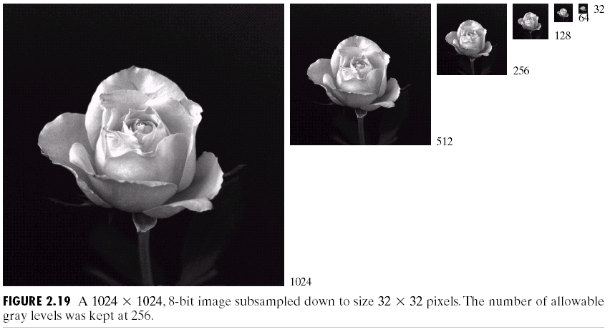
- 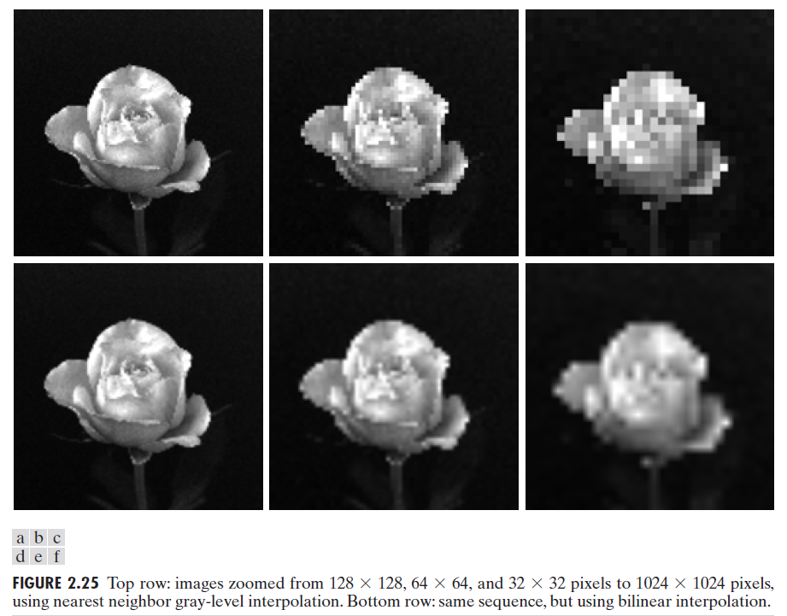
- Gray-level resolution similarly refers to the smallest discernible change in gray level(or intensity level) or number of gray levels used to represent the image.
- Quantization is the principal factor determining the gray-level resolution of an image i.e. Higher the gray-level resolution(tonal resolution) more are the number of quantized levels.
- The number of gray levels is usually an integer power of 2 –
L = 2^{k} where, k is no. of bits
- Gray level resolution is usually given in terms of the number of bits used to store each pixel value (or gray level).
- In general, an L-level digital image of size M*N have a spatial resolution of M*N pixels and a gray-level resolution of L levels.
clc;
clear all;
close all;
im=imread('Lenna.jpg');
%figure,imshow(im);

%im=rgb2gray(imread('Lenna.jpg'));
imj=rgb2gray(im);
figure,imshow(imj);

%figure;
%subplot(2,3,1);imshow(im);subplot(2,3,2);imshow(imj);
im1=imresize(imj, [1024,1024]);
figure;imshow(im1);
im2=imresize(im1, [1024,1024]/2);
figure;imshow(im2);
im3=imresize(im1, [1024,1024]/4);
figure;imshow(im3);
im4=imresize(im1, [1024,1024]/8);
figure;imshow(im4);
im5=imresize(im1, [1024,1024]/16);
figure;imshow(im5);
im6=imresize(im1, [1024,1024]/32);
figure;imshow(im6);
%figure;
subplot(2,3,1);imshow(im1);title('1024 x 1024');
subplot(2,3,2);imshow(im2);title('512 x 512');
subplot(2,3,3);imshow(im3);title('256 x 256');
subplot(2,3,4);imshow(im4);title('128 x 128');
subplot(2,3,5);imshow(im5);title('64 x 64');
subplot(2,3,6);imshow(im6);title('32 x 32')

Practical 5
Aim: Program to implement Point processing operation – Negation of an image and Thresholding of an image
Theory:
- Gray-level transformations are among the simplest of all image enhancement techniques.
- The values of pixels, before and after processing, will be denoted by r and s, respectively.
- These values are related by an expression of the form
s=T(r),
where T is a transformation that maps a pixel value r into a pixel value s.
- There are different kinds of grey level transformations
- Three of the most common are:
  - Linear
    - Negative/Identity transformations
  - Logarithmic
    - Log/Inverse log transformations
  - Power law
    - nth power/nth root transformations

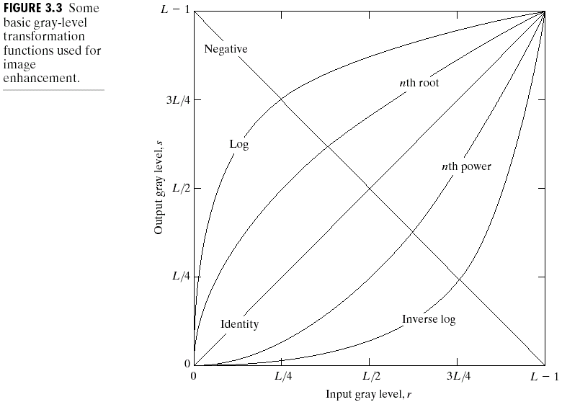
- Image Negatives: The negative of an image with gray levels in the range [0,L-1]is obtained by using the negative transformation shown in Fig., which is given by the expression:
s = (L – 1) – r
- Reversing the intensity levels of an image in this manner produces the equivalent of a photographic negative.
- This type of processing is particularly suited for enhancing white or gray detail embedded in dark regions of an image, especially when the black areas are dominant in size.

- Thresholding: Thresholding transformations are particularly useful for segmentation in which we want to isolate an object of interest from a background
- If r1=r2, s1=0and s2=L-1, the transformation becomes a thresholding function that creates a binary image.
- Here T(r) produces two-level (binary) image

Fig(a) original image
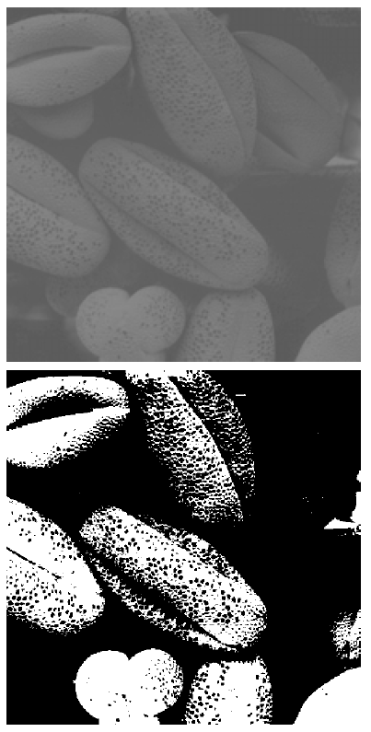
Fig(b) Threshold image
% Matlab program for image negative
clc;
clear all;
close all;
x=rgb2gray(imread('lena2.bmp'));
subplot(1,2,1)
imshow(x);
title('Input Image')
[a,b]=size(x);
for i=1:a
for j=1:b
n(i,j)=255-x(i,j);
end
end
subplot(1,2,2)
imshow(n)
title('Negative')

% Matlab program for image thresholding

clc;
clear all;
close all;
x=rgb2gray(imread('lena2.bmp'));
%Y=rgb2gray(imread('lena2.bmp'));
%subplot(1,2,1)
figure,imshow(x);
title('Input Image');
t=input('Enter threshold value=')
[a b]=size(x);
for i=1:a
for j=1:b
if (x(i,j)<=t)
y(i,j)=0;
else
y(i,j)=255;
end
end
end
%subplot(1,2,2)
figure,imshow(y)
title('Thresholded Image')

Practical 6
Aim: Program to implement Contrast Stretching operation

Theory:
- Low-contrast images can result from poor illumination, lack of dynamic range in the imaging sensor, or even wrong setting of a lens aperture during image acquisition.
- The idea behind contrast stretching is to increase the dynamic range of the gray levels in the image being processed.
- Figure shows a typical transformation used for contrast stretching.
- The locations of points (r1, s1) and (r2, s2) control the shape of the transformation.
- If r1=s1 and r2=s2, the transformation is a linear function that produces no changes in gray levels.
- If r1=r2, s1=0and s2=L-1, the transformation becomes a thresholding function that creates a binary image
- In general, r1 <= r2 and s1 <= s2 is assumed so that the function is single valued and monotonically increasing thus affecting its contrast

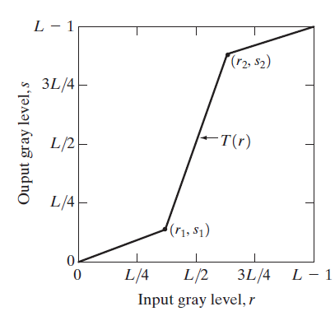

% Matlab program for contrast stretching
clc;
clear all;
close all;
I=rgb2gray(imread('Lenna.jpg'));
subplot(1,2,1)
imshow(I);
title('Input Image')
[r,c]=size(I);

for i=1:r
for j=1:c
if (I(i,j)<=50)
k(i,j)=(I(i,j)*0.5);
elseif (I(i,j)>=80 && I(i,j)<=255)
x=(I(i,j)*1.5);
if (x > 255)
k(i,j)=255;
else
k(i,j)=x;
end
else
k(i,j)=I(i,j);

end
end
end
subplot(1,2,2)
imshow(k);
title('Contrast Stretching')

Practical 7
Aim: Program to implement Bit-plane Slicing

Theory:
- Instead of highlighting gray-level ranges, highlighting the contribution made to total image appearance by specific bits might be desired.
- Imagine that the image is composed of eight 1-bit planes, ranging from bit-plane 0 for the least significant bit to bit-plane 7 for the most significant bit.
- In terms of 8-bit bytes, plane 0 contains all the lowest order bits in the bytes comprising the pixels in the image and plane 7 contains all the high-order bits.
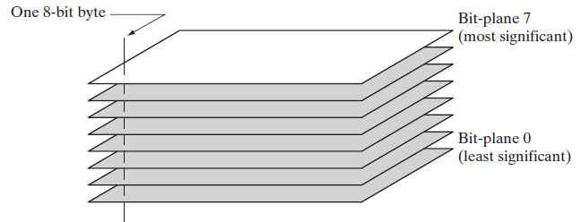
- Higher-order bits usually contain most of the significant visual information
- Lower-order bits contain subtle details
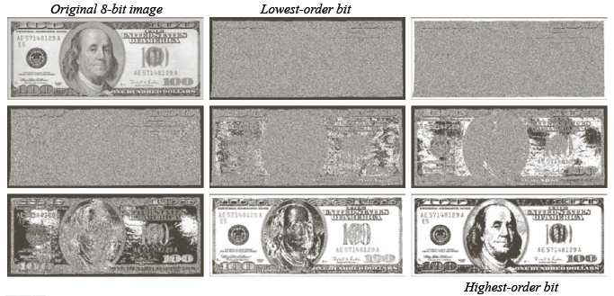

- Observe that four high order bit planes, especially the last two, contain the significant amount of visually significant data.

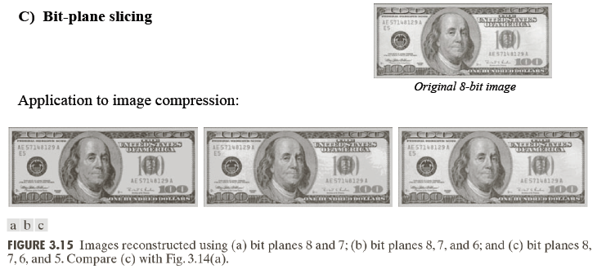

- Hence, by storing just four highest-order bit planes allow us to reconstruct the original image in acceptable detail.
- Storing these four planes instead of the original image requires 50% less storage.
%Matlab program for Bit-plane slicing
x=imread('Lenna.jpg');
x=rgb2gray(x);
subplot(2,5,1);imshow(x);title('original image');
[m n]=size(x);

for i=1:m
for j=1:n
c=bitand(x(i,j),128);
if (c>=1)
y(i,j) = 1;
else
y(i,j) = 0;
end
end
end
%figure,imshow(y)
subplot(2,5,2);imshow(y);title('bit 7 image');
for i=1:m
for j=1:n
c=bitand(x(i,j),64);
if (c>=1)
y(i,j) = 1;
else
y(i,j) = 0;
end
end
end
%figure,imshow(y)
subplot(2,5,3);imshow(y);title('bit 6 image');
for i=1:m
for j=1:n
c=bitand(x(i,j),32);
if (c>=1)
y(i,j) = 1;
else
y(i,j) = 0;
end
end
end
%figure,imshow(y)
subplot(2,5,4);imshow(y);title('bit 5 image');
for i=1:m
for j=1:n
c=bitand(x(i,j),16);
if (c>=1)
y(i,j) = 1;
else
y(i,j) = 0;
end
end
end
%figure,imshow(y)
subplot(2,5,6);imshow(y);title('bit 4 image');
for i=1:m
for j=1:n
c=bitand(x(i,j),8);
if (c>=1)
y(i,j) = 1;
else
y(i,j) = 0;
end
end
end
%figure,imshow(y)
subplot(2,5,7);imshow(y);title('bit 3 image');
for i=1:m
for j=1:n
c=bitand(x(i,j),4);
if (c>=1)
y(i,j) = 1;
else
y(i,j) = 0;
end
end
end
%figure,imshow(y)
subplot(2,5,8);imshow(y);title('bit 2 image');
for i=1:m
for j=1:n
c=bitand(x(i,j),2);
if (c>=1)
y(i,j) = 1;
else
y(i,j) = 0;
end
end
end
%figure,imshow(y)
subplot(2,5,9);imshow(y);title('bit 1 image');
for i=1:m
for j=1:n
c=bitand(x(i,j),1);
if (c>=1)
y(i,j) = 1;
else
y(i,j) = 0;
end
end
end
%figure,imshow(y)
subplot(2,5,10);imshow(y);title('bit 0 image');

Practical 8
Aim: Program to plot a Histogram of an image

Theory:
- The histogram of an image shows us the distribution of grey levels in the image.
- Massively useful in image processing, especially in segmentation.
- Definition: The histogram of a digital image with gray levels from 0 to L-1 is a discrete function :
h(r_{k})=n_{k},
where:
r_{k} is the k^{th} gray level
n_{k} is the number of pixels in the image with that gray level
n is the total number of pixels in the image
k = 0, 1, 2, …, L-1
- Normalized histogram:
p(r_{k})=n_{k}/n
where:
p(r_{k}) is probability of occurrence
sum of all components = 1
- The plot of p_{r}(r_{k}) versus r_{k} is called a histogram
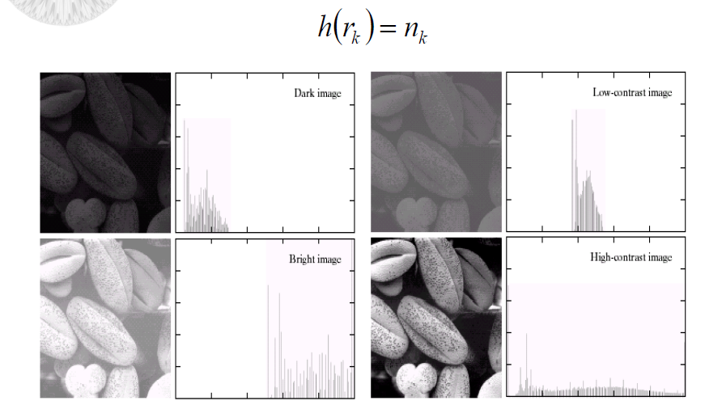

- Fig shows selection of images and their histograms.
- Notice the relationships between the images and their histograms.
- Note that the high contrast image has the most evenly spaced histogram
- Applications of Histograms
Histograms have many uses in image processing:
  - The first use is the analysis of the image. We can predict about an image by just looking at its histogram. Its like looking an x-ray of a bone of a body.
  - The second use of histogram is for brightness purposes. The histograms have wide application in image brightness. Not only in brightness, but histograms are also used in adjusting contrast of an image.
  - Another important use of histogram is to equalize an image.
  - And last but not the least, histogram has wide use in thresholding. This is mostly used in computer vision.

%matlab program to plot a histogram of an image
clc;
clear all;
close all;
a=imread('cameraman.tif');
a=double(a);
[row col]=size(a);
h=zeros(1,256);

{
for n=1:1:row
for m=1:1:col
if a(n,m)==0
a(n,m)=1;
end
end
end
}

for n=1:1:row
for m=1:1:col
t=a(n,m);
h(t)=h(t)+1;
end
end
figure(1)
imshow(a)
figure(2),bar(h);

Practical 9
Aim: Program to implement Filtering in spatial domain –
a)Averaging filter (b)Median filter

Theory:
- Neighbourhood operations simply operate on a larger neighbourhood of pixels than point operations.
- Neighbourhoods are mostly a rectangle around a central pixel.
- Any size rectangle and any shape filter are possible.
- “Filtering” refers to accepting (passing) or rejecting certain frequency components.
- Ex: a filter that passes low frequencies is called low pass filter
- A spatial filter consist of :
  - A neighbourhood
  - A predefined operation that is performed on neighbourhood pixels
The Mechanism of Spatial Filtering:
- The output intensity value at (x,y) depends not only on the input intensity value at (x,y) but also on the specified number of neighbouring intensity values around (x,y)
- Spatial masks (also called window, filter, kernel, template) are used and convolved over the entire image for local enhancement (spatial filtering)
- The size of the masks determines the number of neighboring pixels which influence the output value at (x,y)
- The values (coefficients) of the mask determine the nature and properties of enhancing technique
- Filtering can be given in equation form as :

Notations are based on the image shown below:
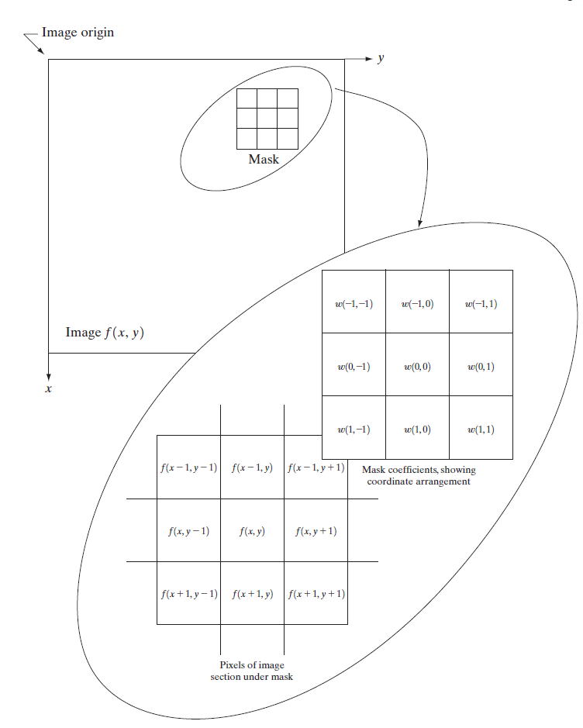
Averaging filter:
- The output (response) of a smoothing, linear spatial filter is simply the average of the pixels contained in the neighborhood of the filter mask.
- These filters sometimes are called
  - averaging filters
  - lowpass filters.
- The idea behind smoothing filters is - replace the value of every pixel in an image by the average of the gray levels in the neighborhood defined by the filter mask.
- It is called Low-pass spatial filtering because smaller (high frequency) details are removed based on neighborhood averaging.
- Application: Reduce noise
- Side effect: Edge blurring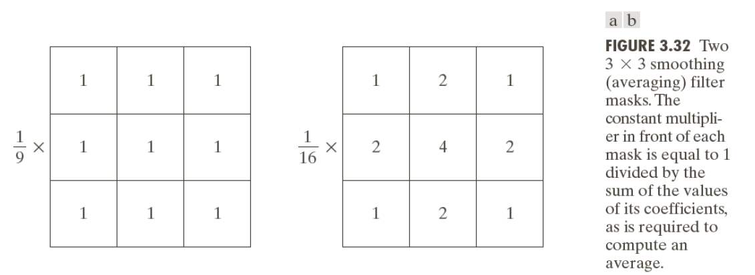
- Ex:
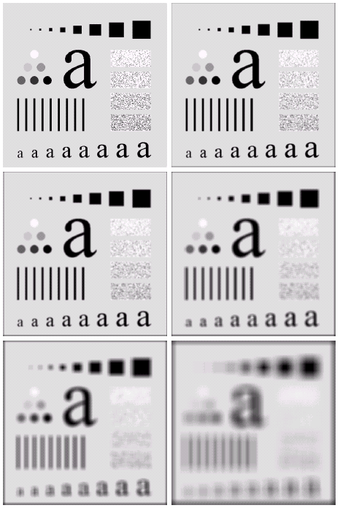
- The image at the top left is an original image of size 500*500 pixels
- The subsequent images show the image after filtering with an averaging filter of increasing sizes - 3, 5, 9, 15 and 35
- Notice how detail begins to disappear.
Median Filter:
- Order-statistics filters are nonlinear spatial filters.
- Their response(output) is based on ordering (ranking) the pixels contained in the image area encompassed by the filter, and then replacing the value of the centre pixel with the value determined by the ranking result.
- Best-known Median filter, Max & Min filtering
- median filter, as its name implies, replaces the value of a pixel by the median of the gray levels in the neighborhood of that pixel
- Median filters are quite popular because, they provide excellent noise-reduction capabilities, with considerably less blurring than linear smoothing filters of similar size.
- Median filters are particularly effective in the presence of impulse noise, also called salt-and-pepper noise.
- The median ,ξ, of a set of values is such that half the values in the set are less than or equal to ξ, and half are greater than or equal to ξ.
- In order to perform median filtering at a point in an image, we do:
  - sort the values of the pixel in the neighborhood,
  - determine their median, and
  - assign this value to that pixel.
- For example, in a 3*3 neighborhood the median is the 5th largest value, in a 5*5 neighborhood the 13th largest value, and so on.
- When several values in a neighborhood are the same, all equal values are grouped.
- Thus, the principal function of median filters is to force points with distinct gray levels to be more like their neighbours

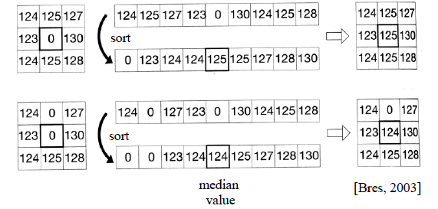

- Ex:
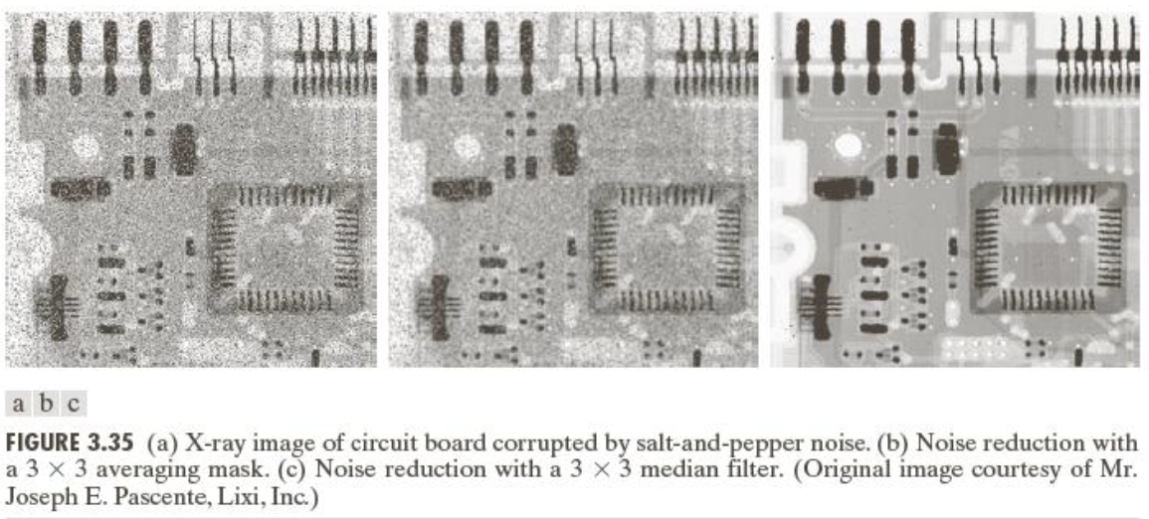

% Matlab program for Spatial Domain Filtering (Averaging filter) %

clc;
clear;
G=imread ('cameraman.tif');
%G=rgb2gray (A);
F=double (G);
Fn=imnoise(G,'gaussian');
a=double (Fn);
w= [1, 1, 1; 1, 1, 1; 1, 1, 1]/900;
[rows,cols]=size (a);
for x=2:rows-1
for y=2:cols-1
al(x,y)=w(1)*a(x-1,y-1)+w(2)*a(x-1,y)+w(3)*a(x- 1,y+1)+w(4)*a(x,y1)+w(5)*a(x,y)+w(6)*a(x,y+1)+w(7)*a(x+1,y+1)+w(8)*a(x+1,y)+w(9)*a(x+1,y+1);
end
end
subplot (1,3,1);
imshow(uint8(G));
title('Input Image');
subplot(1,3,2);
imshow(uint8(Fn));
title('Input Image with Gaussian noise');
subplot (1,3,3);
imshow(al);
title('Output Smoothened Image');

% Matlab program for Spatial Domain Filtering (Median filter) %

clear all;
clc;
I= imread('cameraman.tif');
J=imnoise(I,'salt & pepper',0.02);%Adding noise

a=double(J);
b=a;
[row, col]=size(a);
for x=2:row-1
for y=2:col-1
%%To make a 3*3 =mask into 1*9 mask
a1=[a(x-1,y-1) a(x-1,y+1) a(x,y-1) a(x,y) a(x,y+1) a(x+1,y-1) a(x+1,y) a(x+1,y+1)];
a2=sort(a1);
med=a2(5); % the fifth value is the median
b(x,y)= med;
end
end
figure(1),
imshow(uint8(I));
title('Input Image');

figure(2),
imshow(uint8(J));
title('Input Image with salt and pepper noise');

figure(3),
imshow(uint8(b));
imshow(‘output image’);

Practical 10
Aim: Program to implement Filtering in frequency domain –
a)Low pass filter (b) High pass filter

Theory:
To filter an image in the frequency domain:
  - Compute F(u,v) the DFT of the image
  - Multiply F(u,v) by a filter function H(u,v)
  - Compute the inverse DFT of the result
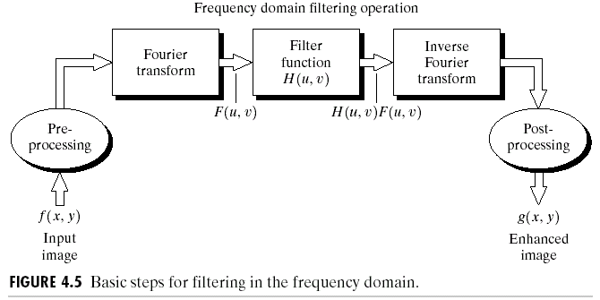
Smoothing Frequency Domain Filters:
- Smoothing is achieved in the frequency domain by dropping out the high frequency components
- The basic model for filtering is:
G(u,v) = H(u,v)F(u,v)
where
F(u,v) is the Fourier transform of the image being filtered and
H(u,v) is the filter transform function
- Low pass filters – only pass the low frequencies, drop the high ones
- Three types of low pass filters: ILPF,BLPF & GLPF
- Ideal Low Pass Filter :
- The transfer function for the ideal low pass filter can be given as:

where D(u,v) is given as:

and D₀ is cut-off frequency
- Simply cut off all high frequency components that are a specified distance D₀ from the origin of the transform

- Changing the distance changes the behaviour of the filter.
- For ILPF cross section, the point of transition between H(u,v)=1 and H(u,v)=0 is called cutoff frequency.
- In above fig, cutoff frequency is D₀.
- Drawback: Ringing effect
Sharpening in the Frequency Domain:
- Edges and fine detail in images are associated with high frequency components
- High pass filters – only pass the high frequencies, drop the low ones
- High pass frequencies are precisely the reverse of low pass filters, so:
- Hhp(u, v) = 1 – Hlp(u, v)
- Three types of high pass filters: IHPF,BHPF & GHPF
- Ideal High Pass Filters: The ideal high pass filter is given as:

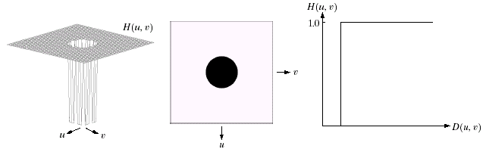
Where, D₀ is the cut off frequency and D(u,v) as before

Fig: Results of Ideal low pass filter

Fig: Results of Ideal high pass filter

%matlab code for ILPF
clear all;
close all;
clc;
am=imread('cameraman.tif');

a=double(am);
[row col]=size(a);
D0=input('Enter the value of the cut-off frequency=');
for u=1:row
for v=1:col
D=((u-(row/2))^2+(v-(col/2))^2)^0.5;
if D<D0
H(u,v)=1;
else
H(u,v)=0;
end
end
end
vv=fft2(a);
vc=fftshift(vv);
x=(vc.*H);
X=abs(ifft2(x));
figure(1), imshow(uint8(am))
figure(2), imshow(uint8(X))
figure(3), imagesc(H),colormap(gray)
%matlab code for IHPF

clear all;
close all;
clc;
am=imread('cameraman.tif');

a=double(am);
[row col]=size(a);
D0=input('Enter the value of the cut-off frequency=');
for u=1:row
for v=1:col
D=((u-(row/2))^2+(v-(col/2))^2)^0.5;
if D<D0
H(u,v)=0;
else
H(u,v)=1;
end
end
end
vv=fft2(a);
vc=fftshift(vv);
x=(vc.*H);
X=abs(ifft2(x));
figure(1), imshow(uint8(am))
figure(2), imshow(uint8(X))
figure(3), imagesc(H),colormap(gray)

Practical 11
Aim: Program for edge detection –a) Prewitt operator (b) Sobel operator
Theory:
- Segmentation is to subdivide an image into its component regions or objects.
- Level of subdivision depends on the problem being solved.
- Segmentation should stop when the objects of interest in an application have been isolated.
- Example: For an air-to-ground target acquisition system interest may lie in identifying vehicles on a road:
  - Segment the road from the image
  - Segment contents of the road down to objects of a range of sizes that correspond to potential vehicles
  - No need to go below this level, or segment outside the road boundary
- Segmentation algorithms generally are based on one of 2 basis properties of intensity values
  - Discontinuity : to partition an image based on sharp changes in intensity (such as edges)
  - Similarity: to partition an image into regions that are similar according to a set of predefined criteria.
- Edge Detection: An edge is a set of connected pixels that lie on the boundary between two regions
- Edge detection is massively important as it is in many cases the first step to object recognition
- First derivatives in image processing are implemented using the magnitude of the gradient.
- The gradient of function f(x,y) is

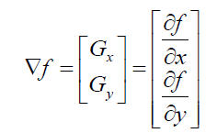
- The magnitude (length) of this gradient vector is given by

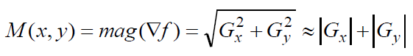
Where, M(x,y) is the gradient image

- Given a 3*3 region of an image the following edge detection filters can be used:

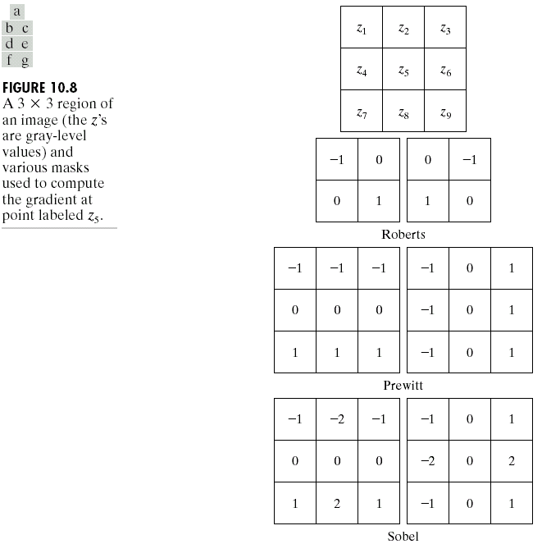
Ex:

% matlab code for edge detection using Prewitt operator
clc;
close all;
clear all;
a=imread('C:\Documents and Settings\student\Desktop\lenna1.bmp');
b=im2double(a);
[m,n]=size(a);

N(1:m,1:n)=0
for i=1:m-2;
for j=1:m-2;
N(i,j)=-1*b(i,j)-1*b(i,j+1)-1*b(i,j+2)+0+0+0+1*b(i+2,j)+1*b(i+2,j+1)+1*b(i+2,j+2);
end;
end;
O(1:m,1:n)=0
for i=1:m-2;
for j=1:m-2;
O(i,j)=-1*b(i,j)+0+1*b(i,j+2)-1*b(i+2,j)+0+1*b(i+1,j+2)-1*b(i+2,j)+0+1*b(i+2,j+2);
end;
end;
figure;
subplot(2,2,1)
imshow(N)
title('Prewit Gx');
subplot(2,2,2)
imshow(O)
title('Prewit Gy');
Z=N+O;
subplot(2,2,3)
imshow(Z)
title('Prewit Gx+Gy');
subplot(2,2,4)
imshow(b)
title('Original Image');

% matlab code for edge detection using Sobel operator
clc;
close all;
clear all;
a=imread('C:\Documents and Settings\student\Desktop\lenna1.bmp');
b=im2double(a);
[m,n]=size(a);

P(1:m,1:n)=0
for i=1:m-2;
for j=1:m-2;
P(i,j)=-1*b(i,j)-2*b(i,j+1)-1*b(i,j+2)+0+0+0+1*b(i+2,j)+2*b(i+2,j+1)+1*b(i+2,j+2);
end;
end;
R(1:m,1:n)=0
for i=1:m-2;
for j=1:m-2;
R(i,j)=-1*b(i,j)+0+1*b(i,j+2)-2*b(i+1,j)+0+2*b(i+1,j+2)-1*b(i+2,j)+0+1*b(i+2,j+2);
end;
end;
figure;
subplot(2,2,1)
imshow(P)
title('Sobel Gx');
subplot(2,2,2)
imshow(R)
title('Sobel Gy');
Y=P+R;
subplot(2,2,3)
imshow(Y)
title('Soble Gx+Gy');
subplot(2,2,4)
imshow(b)
title('Original Image');

